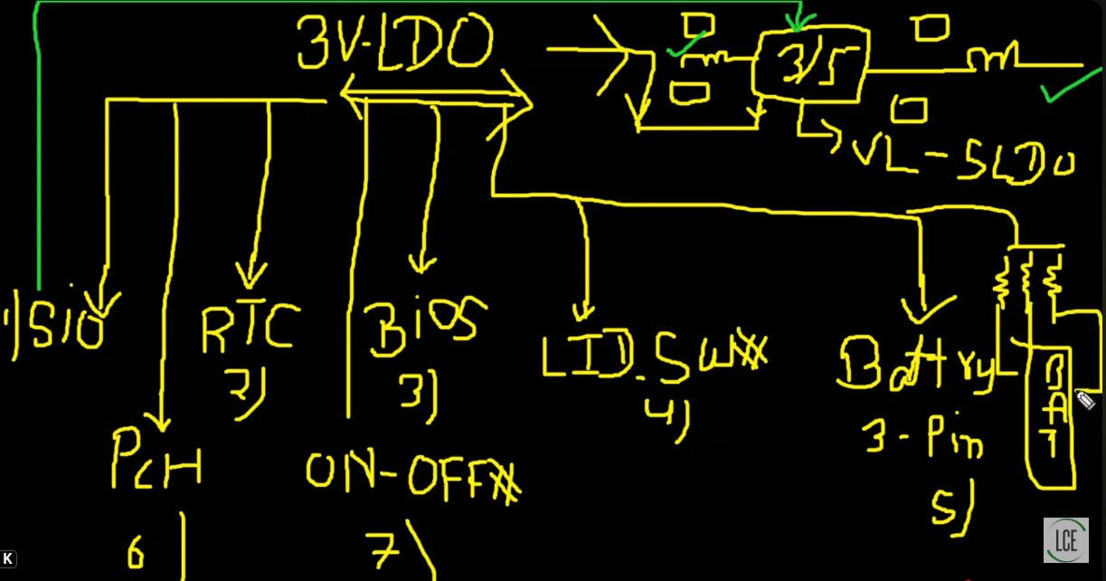

- SIO – SIO se EN 3/5 Stepdown me jata hai
- PCH – PCH ko activate krne ke liye
- RTC – RTC Diode(dual ) se out hota hai
- BIO – SIO jo bhi kaam krta vo bios se puch kr krta hai jese 3/5 Stepdown ke liye EN bejta hai.
- LID Sw# - 3V LDO hamesha hota hai.. Sleep mode me 0V(disabled)
- Battery – 3 pins par aata pull up register(high value ~2.2kh) se SMD, SMS Temp par
- ON/Off- button press low and release high

